**Object Detection, Tracking and Speed Estimation using CCTV Footages**

**AMIRTHAVARSHINI V**

**Refer my repo for code:** [**amirtha19/Hacktech (github.com)**](https://github.com/amirtha19/Hacktech)

**ABSTRACT:**

This project proposes an advanced surveillance system for monitoring vehicular activities in urban environments using state-of-the-art deep learning techniques. The focus is on leveraging the You Only Look Once (YOLO) object detection algorithm and darknet framework, specifically customized for the DETRAC (Detection and Tracking in the Wild: A Benchmark) dataset, to achieve accurate and real-time detection, tracking, and speed estimation of vehicles in CCTV videos.

**Dataset Description:**

It is a widely used benchmark dataset in computer vision research, specifically designed for the evaluation of object detection and tracking algorithms in unconstrained, real-world traffic scenarios. The dataset includes high-resolution video sequences captured by surveillance cameras mounted in various locations, such as urban streets and intersections. The videos cover diverse scenarios with varying traffic densities, occlusions, and lighting conditions.

**Objective:**

* To enhance the speed estimation capabilities of the integrated vehicle detection and tracking system using a custom-trained YOLO model on the DETRAC dataset, with a focus on achieving high accuracy and robust performance in diverse urban traffic scenarios.
* Optimize the speed estimation algorithm to operate in real-time, allowing the integrated system to provide timely and up-to-date information on vehicle speeds. Implement parallel processing and other optimization techniques to ensure low latency in speed estimation without compromising accuracy.
* Define and employ comprehensive performance metrics for speed estimation, Root Mean Squared Error (RMSE), and accuracy at different speed ranges. Use these metrics to quantitatively assess the effectiveness of the speed estimation module and identify areas for further improvement.

**Methodology:**

**Speed estimation:**

* Euclidean Distance Formula:

The Euclidean distance formula calculates the straight-line distance between two points in a two-dimensional space. In this context, it computes the pixel distance between two locations (assumed to be in the format (x, y)).

* Pixels per Meter (ppm):

ppm is a conversion factor that represents the number of pixels equivalent to one meter. It's used to convert the pixel distance to meters.

* Converting Pixel Distance to Meters:

d_meters is the distance between the two locations in meters, obtained by dividing the pixel distance by the pixels per meter.

* Time Constant:

time_constant is a factor used for converting the final speed from meters per second to kilometers per hour. The value 15 * 3.6 represents the conversion factor.

* Speed Calculation:

The final speed is calculated using the formula speed = distance / time, where distance is the converted distance in meters and time is the time constant. The result is the estimated speed in kilometers per hour (speed).

**Models:**

* DETRAC Annotation Conversion and YOLO Model Training:

The DETRAC annotations, provided in XML format, are converted to text format to facilitate custom training of the YOLO model. The YOLO model is then trained on videos annotated with DETRAC, encompassing object detection and tracking. The trained model is subsequently employed to predict the speed of vehicles within the video.

* Pre Trained YOLOv8 Model:

A pre-trained YOLOv8 model, already trained for multiple object detection and tracking, is utilized to detect the speed of vehicles in videos.

**Results:**

Trained model using detrac works better than others. The results are

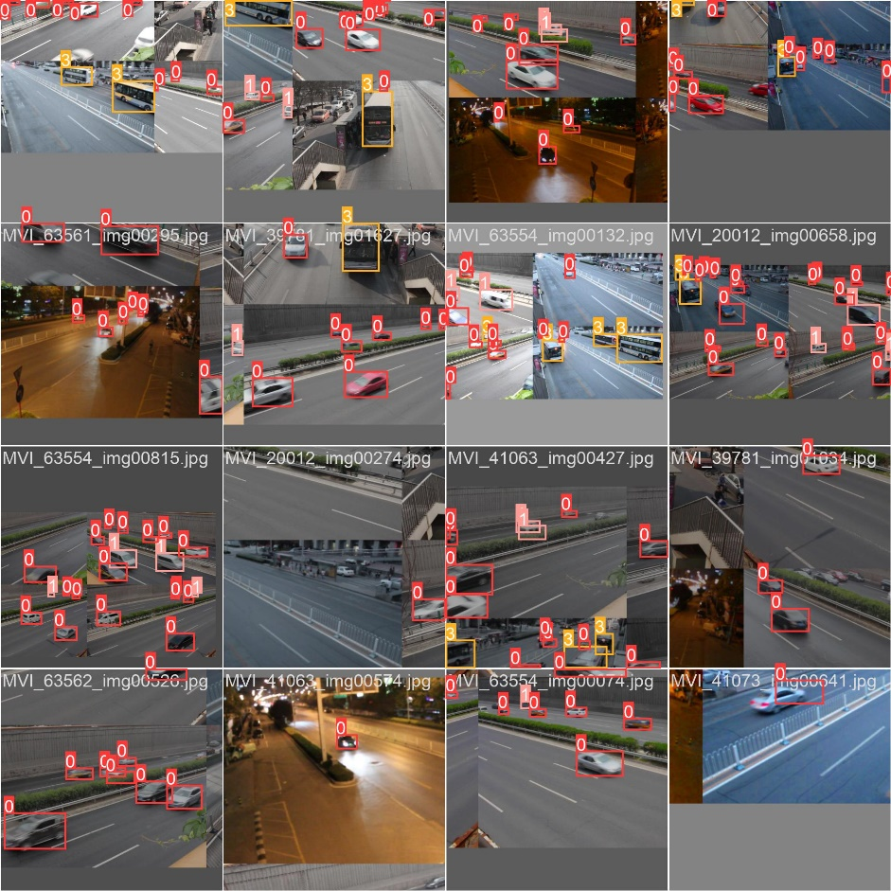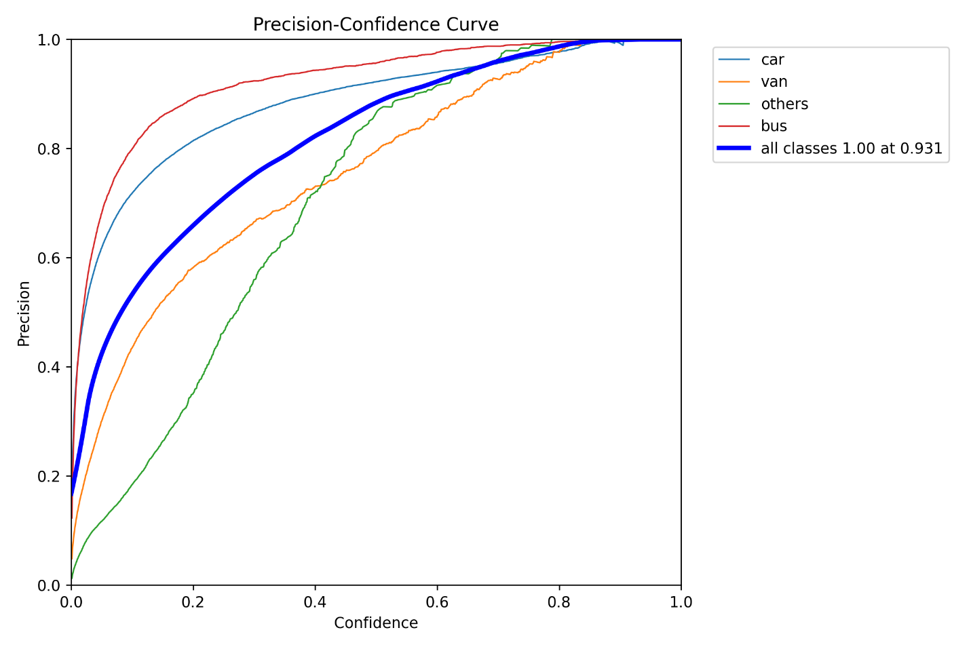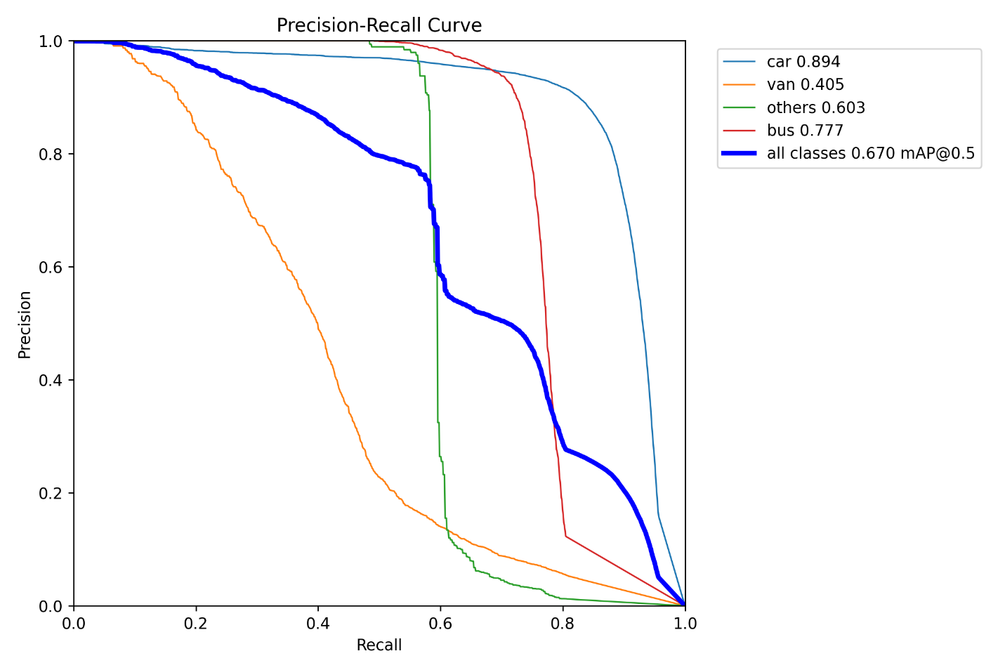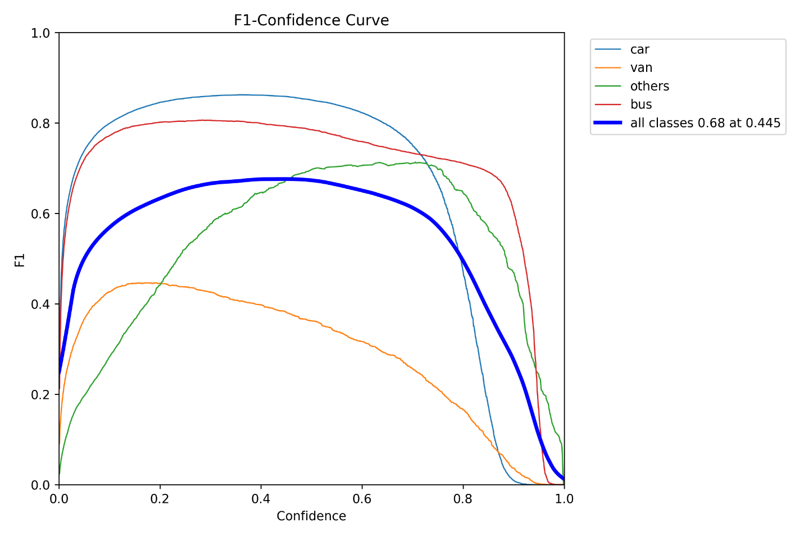

**Future works:**

Apart from speed estimation, we counted the objects passing using a line drawn using cv.

**Conclusion:**

This study presents an integrated approach for vehicle speed prediction in videos, incorporating DETRAC and RoboFlow annotations with YOLO models. The results obtained from each approach are compared, providing insights into the efficacy of the proposed methodology. The findings contribute to the advancement of vehicle speed prediction techniques in computer vision applications.